Executive Summary

- Overview

투자자가 회사에 대해 이해할수 있도록 아래의 내용을 포함하여 핵심 내용만 기재

“회사가 타겟하고 있는 시장(Market), 타겟 고객(Customers), 고객에게 제공하는 가치(Value Proposition), 그 가치를 제공할 수 있게 된 기술(Technologies), 그러한 가치제안이 왜 독특하고 차별화되어 있는지(Uniquenss), 업력(Years since inception)을 기재”
투자자가 한눈에 이해할수 있도록 핵심 포인트는 Bold체로 기재

예> Tempus AI
Tempus AI is a leading precision medicine company that harnesses artificial intelligence to transform how clinical and molecular data are used in patient care and drug development. By integrating the world’s largest multimodal real-world dataset—spanning clinical records, genomics, imaging, and molecular insights—Tempus enables physicians to deliver personalized treatments and empowers pharma/biotech partners to accelerate innovation. Founded in 2015, the company has rapidly scaled into a global leader, setting new standards for AI-driven healthcare.

- Highlights

- 어떤 역량을 가진 팀이며 스타트업으로서 어떤 변화를 일으킬 vision/mission이 있는지 설명
- 타겟 마켓은 얼마나 크고 빠르게 성장하는지 설명
- 가치제안은 고객이 얼마나 큰 가치를 경험하는지 설명
- 핵심 기술과 해자는 무엇인지 설명(당사만 할수 있는 unique 기술/노하우/데이터 자산/높은 교체비용 등)
- 성장 전략/기업가치 증대 전략은 무엇인지 설명
- Go-to-market과 가격 정책이 무엇인지 설명

예> Tempus AI
- Team & Vision: Founded by Eric Lefkofsky, Tempus brings top-tier expertise in AI, healthcare, and data science, with a mission to make precision medicine accessible to every patient.
- Market: Positioned in the $150B+ precision medicine and AI healthcare market, growing at double-digit CAGR.
- Value Proposition: Offers the world’s largest multimodal real-world dataset (clinical, genomic, imaging) and delivers real-time, personalized insights directly into clinical workflows.
- Technology & Moat: Proprietary AI/ML and NLP platform structures massive unstructured data, creating a defensible network effect and unmatched integration across hospitals and pharma.
- Scale & Growth Drivers: SaaS-based recurring revenue, pharma partnerships, high-margin data licensing, and expansion into neurology, cardiology, and rare diseases drive enterprise value.
- Go-to-Market & Pricing: Direct SaaS sales to hospitals, data licensing to pharma/biotech, and subscription-based tiered pricing enable scalable growth.
- Achievement(Key Metrics & Performance)
현재까지 보여준 핵심 성과 지표(매출액, 매출액 성장률과 원인, 비재무 지표, 주요 계약 등 투자자가 impression을 느낄만한 핵심 지표를 기재)

예> Tempus AI
- Revenue Growth: Reported $314.6M in Q2 2025 revenue, up 89.6% year-over-year.
- Genomics Expansion: Genomics revenue reached $241.8M (+115.3% YoY), with Oncology testing at $133.2M (~26% unit growth) and Hereditary testing at $97.3M (~32% unit growth).
- Profitability Improvement: Gross profit rose to $195.0M (+158.3% YoY). Adjusted EBITDA loss narrowed from –$31.2M in Q2 2024 to –$5.6M in Q2 2025.
- Scale of Data:
  - Over 4,500 healthcare system integrations.
  - More than 40M patient records, including ~9M de-identified records.
  - 350 petabytes of clinical and molecular data.
- Contracts & Retention:
  - $940M in Remaining Contract Value as of year-end 2024.
  - Net revenue retention at ~140%, demonstrating strong upsell and expansion from existing customers.

- Funding Plan
금번 라운드 투자 희망금액, 지난 라운드 투자 밸류/금액, 금번 라운드 공동 투자자, 예상 자금사용 내역 등을 기재
- Target Raise (Amount to be Raised): The company is seeking to raise [X million USD] in the current financing round.
- Last Round Valuation & Investment: In the previous round, the company was valued at [Y million USD pre-/post-money], with [Z million USD] invested.
- Committed Investors (This Round): The current round already has commitments from [Investor A, Investor B, …].
- Use of Proceeds: Funds will be allocated to R&D expansion, clinical trial execution, commercialization efforts, talent acquisition, and global market expansion.
예> Tempus AI
- Target Raise: Approximately $410.7 million through its IPO.
- Last Round Valuation & Investment: Raised about $200 million in April 2024 at a post-money valuation of $8.89 billion.
- Committed Investors (This Round): Backed by major institutional investors, including SoftBank.
- Use of Proceeds:
  - Expand genomics and diagnostic testing capacity.
  - Scale data services and AI infrastructure to handle more multimodal datasets.
  - General corporate purposes including R&D, talent acquisition, and potential acquisitions.

See Below

Executive Summary

- Overview

Tempus AI is a leading precision medicine company that harnesses artificial intelligence to transform how clinical and molecular data are used in patient care and drug development. By integrating the world’s largest multimodal real-world dataset—spanning clinical records, genomics, imaging, and molecular insights—Tempus enables physicians to deliver personalized treatments and empowers pharma/biotech partners to accelerate innovation. Founded in 2015, the company has rapidly scaled into a global leader, setting new standards for AI-driven healthcare.

- Highlights

- Team & Vision: Founded by Eric Lefkofsky, Tempus brings top-tier expertise in AI, healthcare, and data science, with a mission to make precision medicine accessible to every patient.
- Market: Positioned in the $150B+ precision medicine and AI healthcare market, growing at double-digit CAGR.
- Value Proposition: Offers the world’s largest multimodal real-world dataset (clinical, genomic, imaging) and delivers real-time, personalized insights directly into clinical workflows.
- Technology & Moat: Proprietary AI/ML and NLP platform structures massive unstructured data, creating a defensible network effect and unmatched integration across hospitals and pharma.
- Scale & Growth Drivers: SaaS-based recurring revenue, pharma partnerships, high-margin data licensing, and expansion into neurology, cardiology, and rare diseases drive enterprise value.
- Go-to-Market & Pricing: Direct SaaS sales to hospitals, data licensing to pharma/biotech, and subscription-based tiered pricing enable scalable growth.
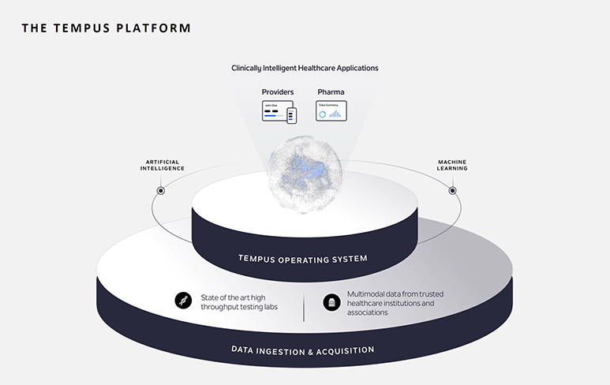
- Achievement(Key Metrics & Performance)

- Revenue Growth: Reported $314.6M in Q2 2025 revenue, up 89.6% year-over-year.
- Genomics Expansion: Genomics revenue reached $241.8M (+115.3% YoY), with Oncology testing at $133.2M (~26% unit growth) and Hereditary testing at $97.3M (~32% unit growth).
- Profitability Improvement: Gross profit rose to $195.0M (+158.3% YoY). Adjusted EBITDA loss narrowed from –$31.2M in Q2 2024 to –$5.6M in Q2 2025.
- Scale of Data:
  - Over 4,500 healthcare system integrations.
  - More than 40M patient records, including ~9M de-identified records.
  - 350 petabytes of clinical and molecular data.
- Contracts & Retention:
  - $940M in Remaining Contract Value as of year-end 2024.
  - Net revenue retention at ~140%, demonstrating strong upsell and expansion from existing customers.

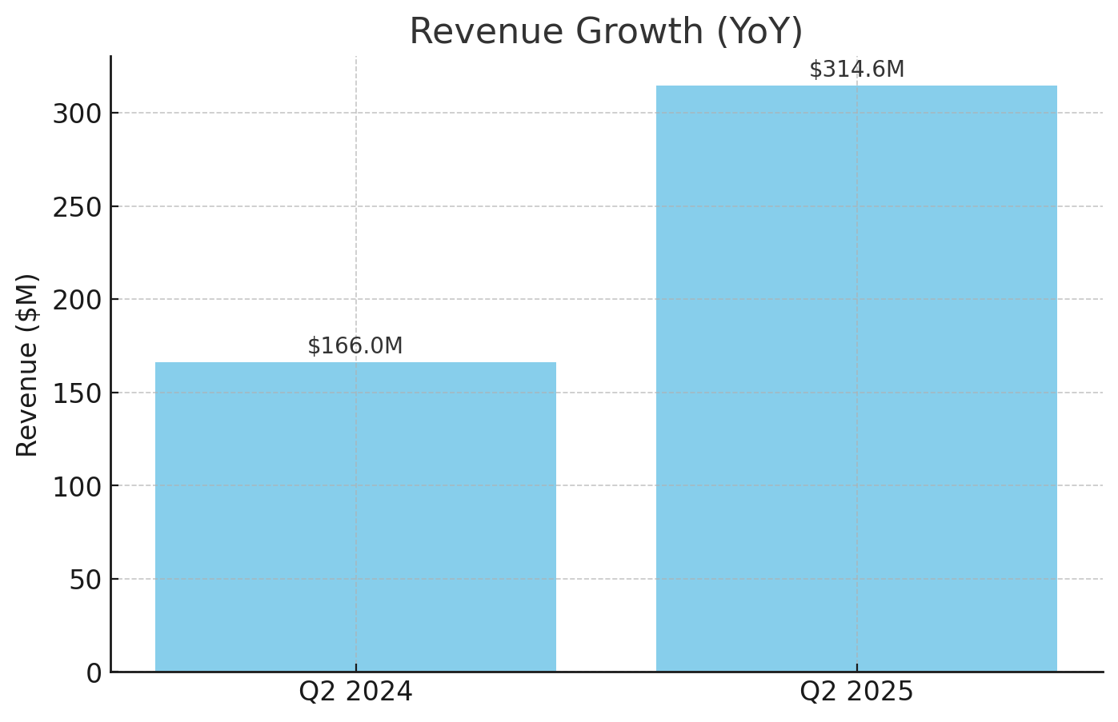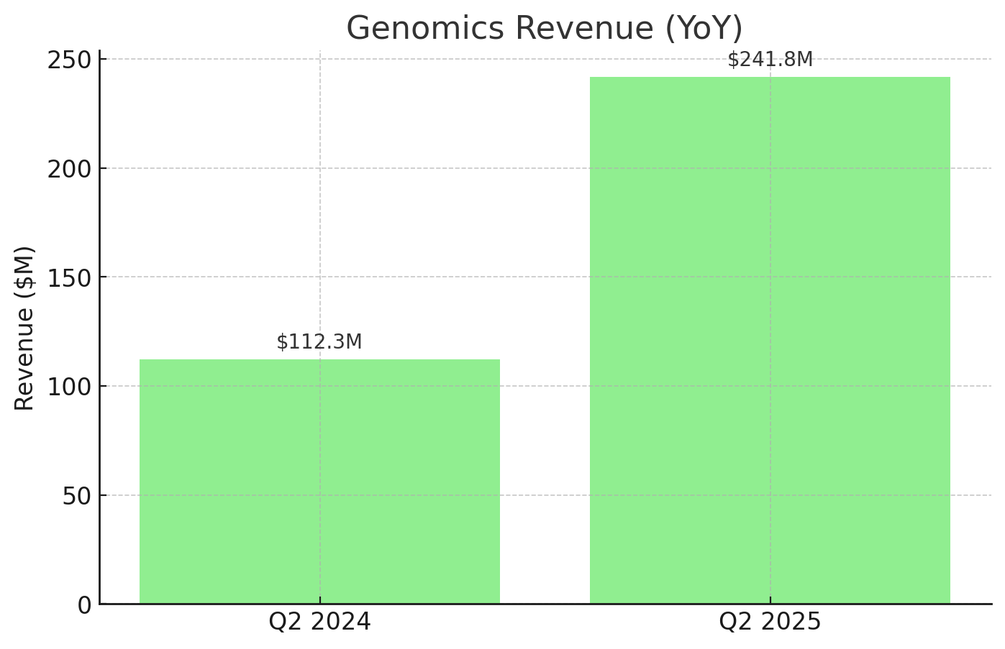

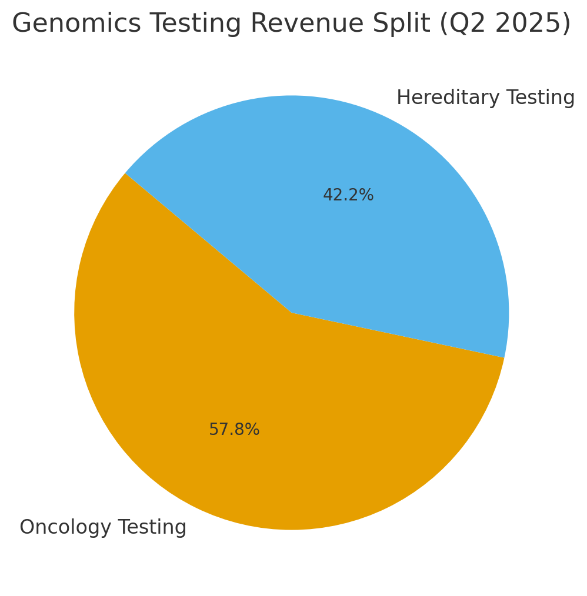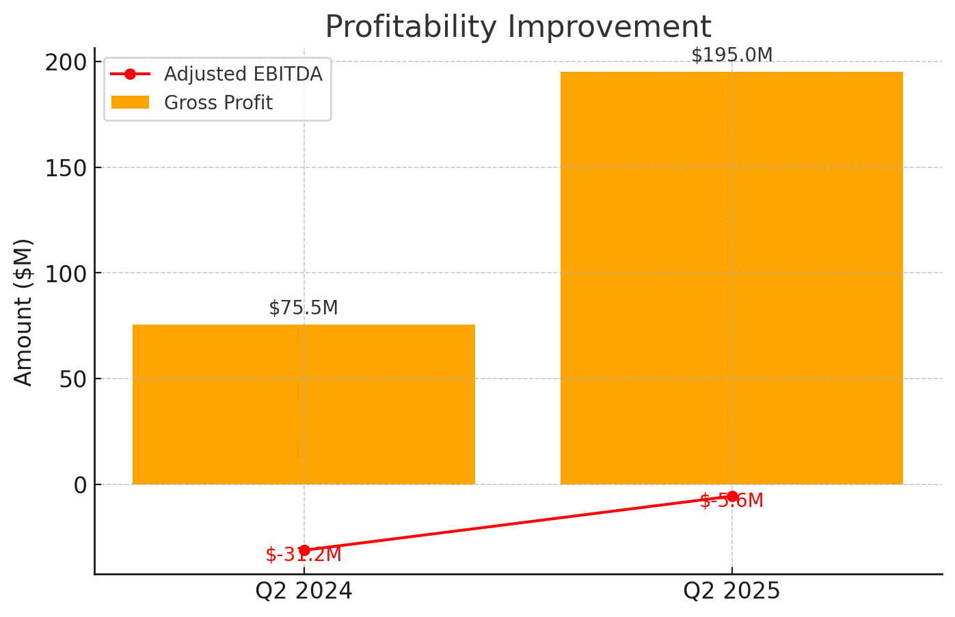
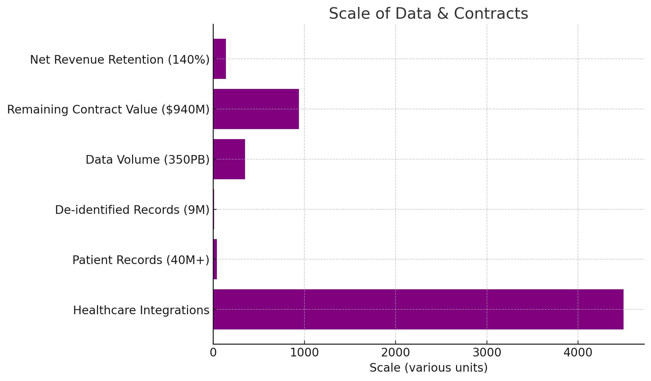

- Funding Plan

- Target Raise: Approximately $410.7 million through its IPO.
- Last Round Valuation & Investment: Raised about $200 million in April 2024 at a post-money valuation of $8.89 billion.
- Committed Investors (This Round): Backed by major institutional investors, including SoftBank.
- Use of Proceeds:
  - Expand genomics and diagnostic testing capacity.
  - Scale data services and AI infrastructure to handle more multimodal datasets.
  - General corporate purposes including R&D, talent acquisition, and potential acquisitions.

